**SQL COMMANDS**

**SCETION 6**

**HIREARICHAL LEVEL**

select level e_name,emp_no,job_id

from employee

start with job_id=9

connect by prior emp_no =job_id

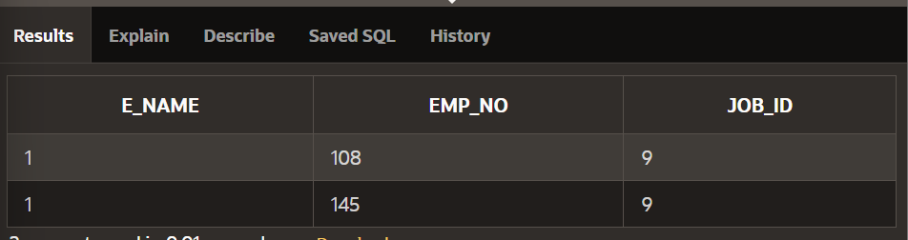

**HIERARICHAL START WITH**

select e_name,emp_no,job_id

from employee

start with job_id=9

connect by prior emp_no =job_id

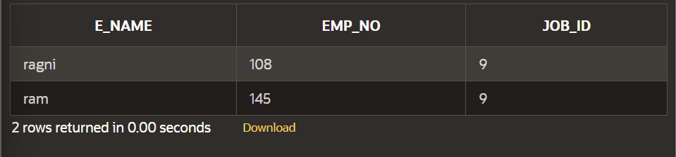

**FULL OUTER JOIN**

select e.e_name,j.job_id,j.job_name

from employee e full outer join job j

on (e.job_id=j.job_id);

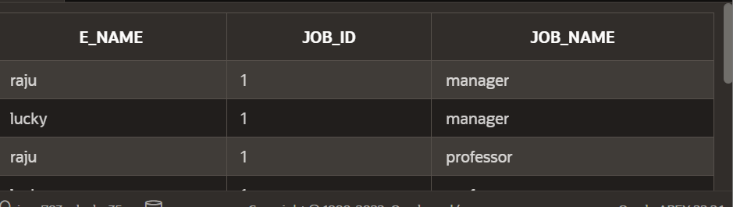

**RIGHT OUTER JOIN**

select e.e_name,j.job_id,j.job_name

from employee e right outer join job j

on (e.job_id=j.job_id);

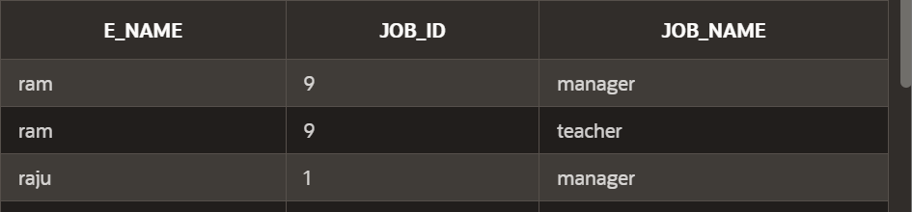

**LEFT OUTER JOIN**

select e.e_name,j.job_id,j.job_name

from employee e left outer join job j

on (e.job_id=j.job_id);

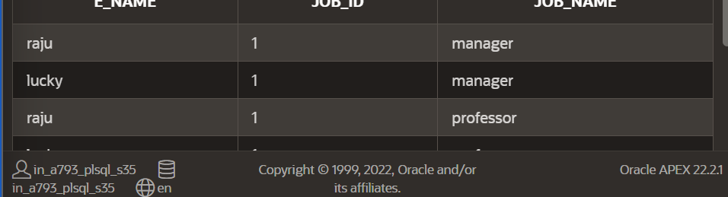

**ON CLAUSE**

select e_name,job_name

from employee e join job j

on (e.job_id=j.job_id);

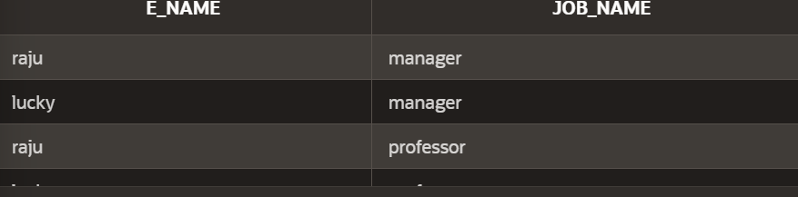

**USING CLAUSE**

select e_name,job_id,job_name

from employee join job using (job_id);

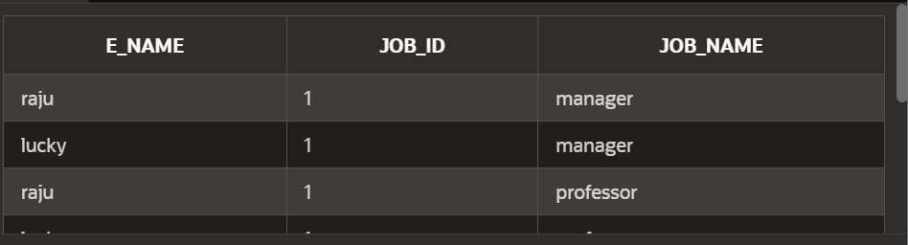

CROSS JOIN

select e_name,job_name

from employee cross join

job;



NATURAL JOIN:

select e_name,job_id,job_name

from employee natural join job

where job_id<9;

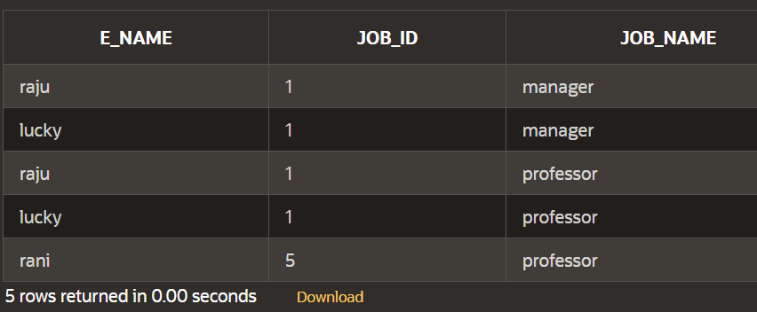

**SYS DATE:**

select sysdate

from dual;

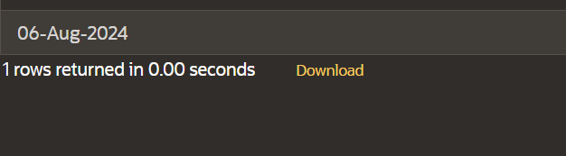

**SECTION 5**

**NVL FUNCTION:**

select id,nvl(dept,'not assigned')

from singer;

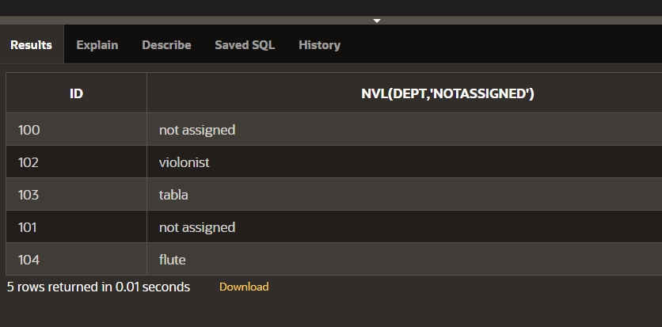

**NVL DATE:**

SELECT NVL(TO_CHAR(hiredate, 'YYYY-MM-DD'), 'no date')

FROM singer;

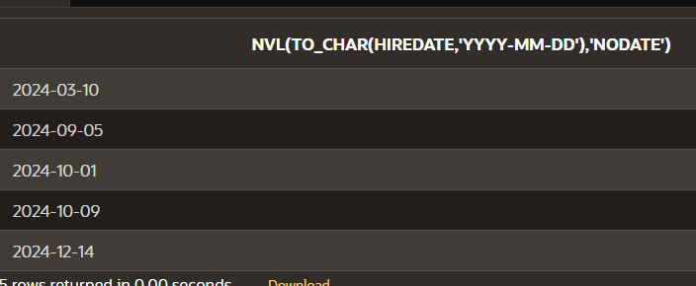

**CHARACTER TO DATE**

select to_date('may10,1989','fxmondd,yyyy') as "convert"

from dual;

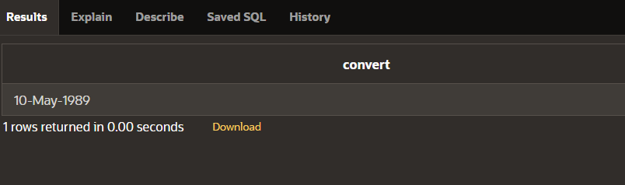

**NUMBER TO CHARACTER:**

select to_char(salary,'$99,999')

from singer;

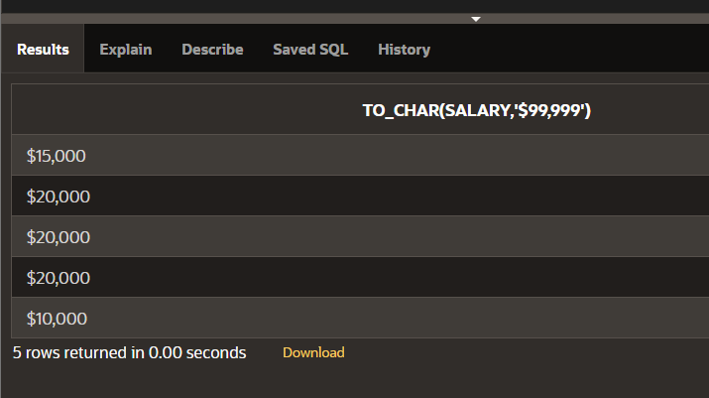

**DATE TO CHARACTER:**

select to_char(hiredate,'month dd,yyyy')

from singer;

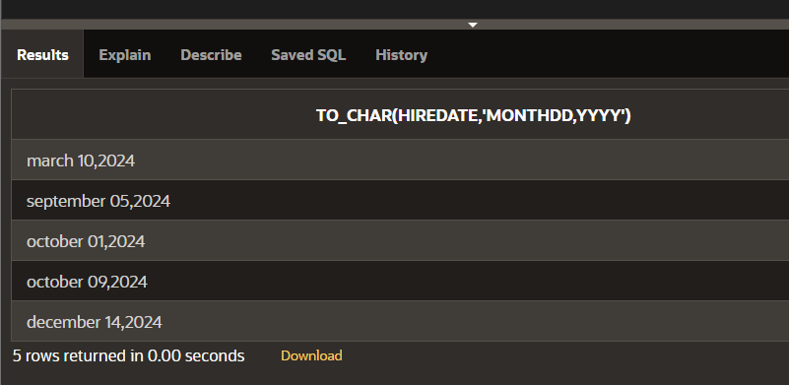

**DATE FUNCTION**

select id,name,hiredate,round(months_between(sysdate,hiredate)) as tenure, add_months(hiredate,6) as review, next_day(hiredate,'friday'),last_day(hiredate)

from singer;

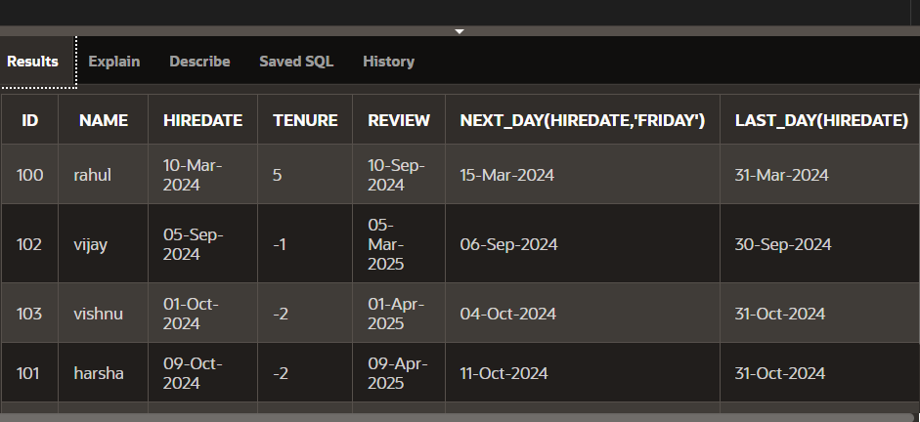

**SECTION 4**

**TRUNC**

select hiredate,

trunc(hiredate,'month')

from singer;

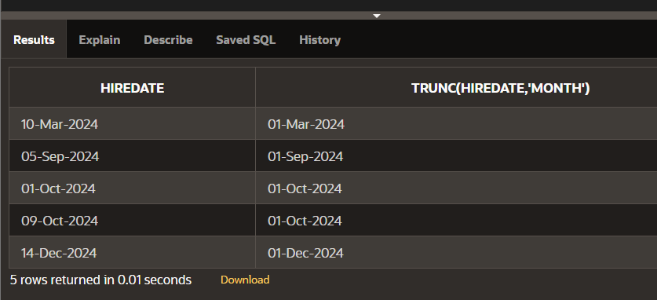

**ROUND TO HIREDATE**

select hiredate,

round(hiredate,'month')

from singer;

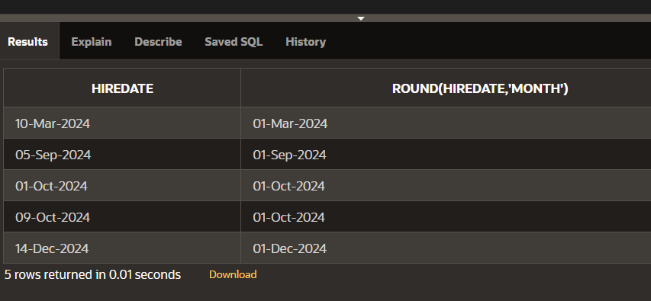

**LAST DAY**

select last_day(sysdate)

from dual;

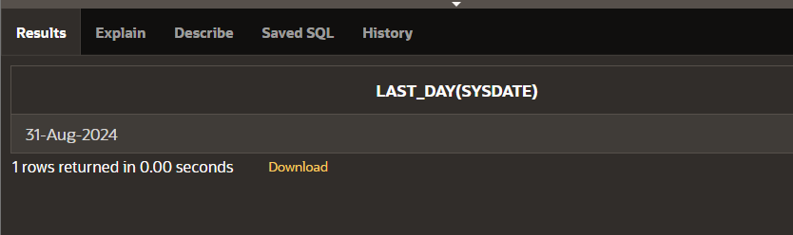

**NEXT DAY**

select next_day(sysdate,'monday')

from dual;

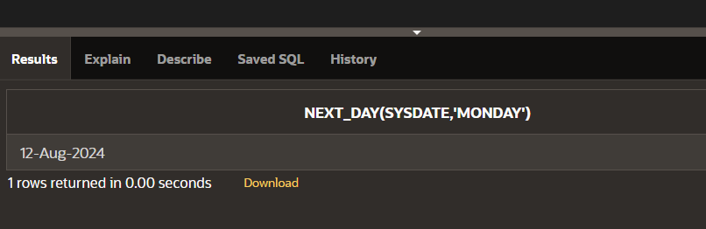

**ADD MONTHS**

select add_months(sysdate,5)

from dual;

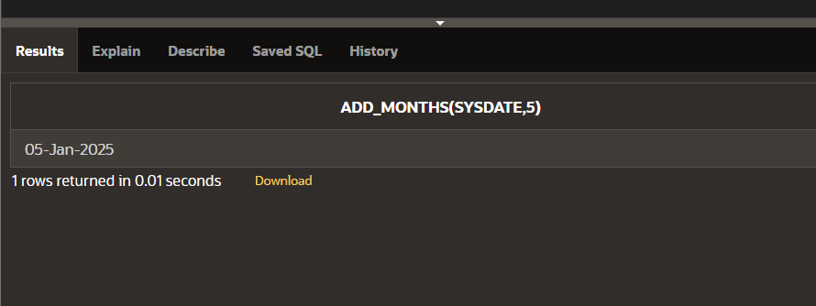

**MONTHS BETWEEN**

select id,name

from singer

where months_between

(sysdate,hiredate)<100;

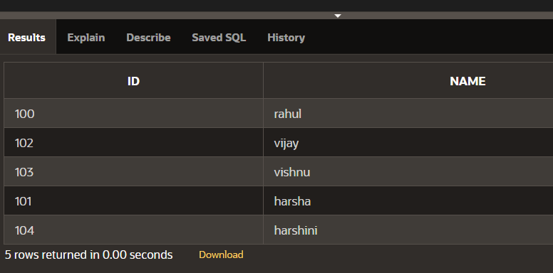

**SECTION_7**

**EQUIJOIN AND CARTESIAN PRODUCT**

CREATE TABLE employ(

eno VARCHAR(14),

ename VARCHAR(14),

eadhress VARCHAR(15),

epno VARCHAR(15),

depno VARCHAR(14),

depname VARCHAR(14),

jobid VARCHAR(10),

salary VARCHAR(10),

create_date DATE DEFAULT SYSDATE);

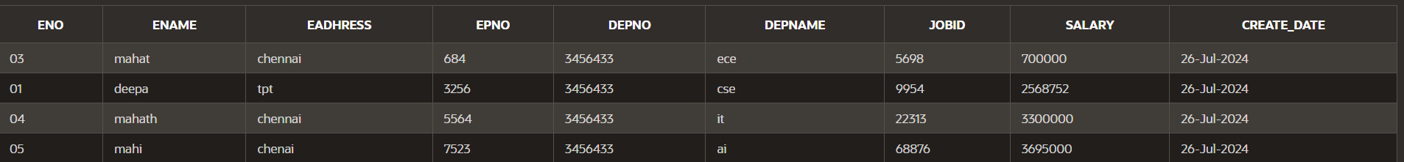

CREATE TABLE jobs (

job_id VARCHAR(10) PRIMARY KEY,

job_title VARCHAR(50) NOT NULL,

min_salary DECIMAL(8, 2),

max_salary DECIMAL(8, 2)

);



**PROPRIEATARY JOINS:**

SELECT employ.ename, jobs.job_title

FROM employ,jobs

WHERE employ.jobid=jobs.job_id;

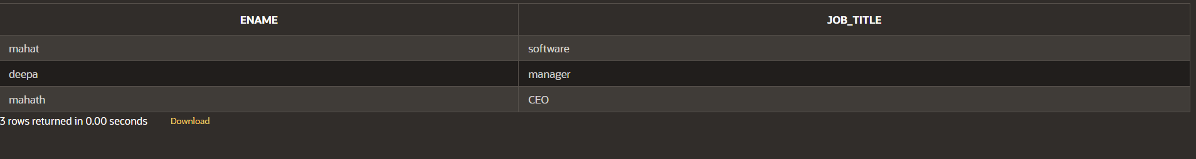

**EQUIJOIN:**

SELECT employ.ename, employ.jobid, jobs.job_title

FROM employ, jobs

WHERE employ.jobid = jobs.job_id;

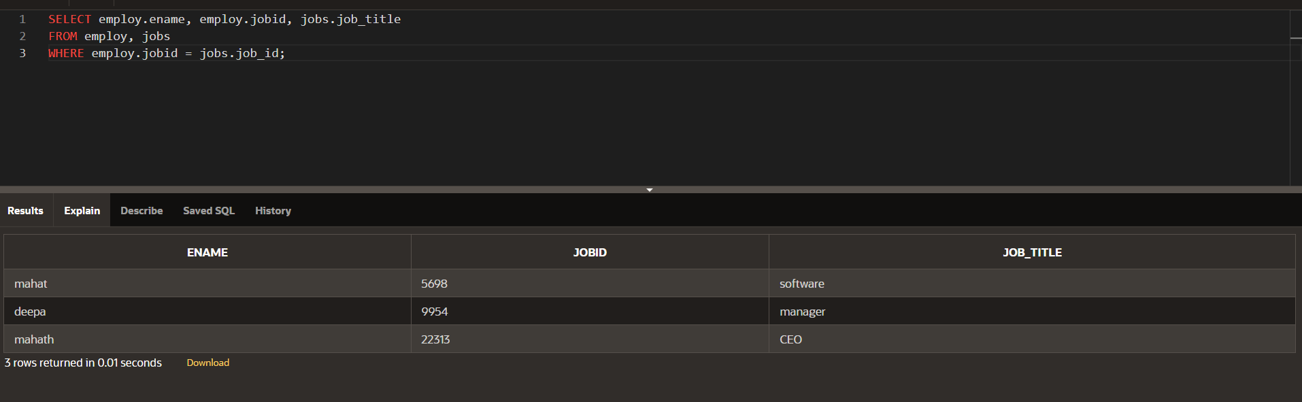

**ALIASES:**

SELECT ename, e.jobid, job_title

FROM employ e, jobs j

WHERE e.jobid = j.job_id

AND depno=3456433;

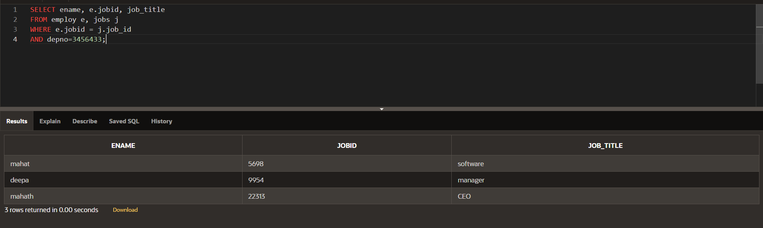

**CARTESIAN PRODUCTJOIN:**

SELECT employ.ename,jobs.job_title

FROM employ,jobs;

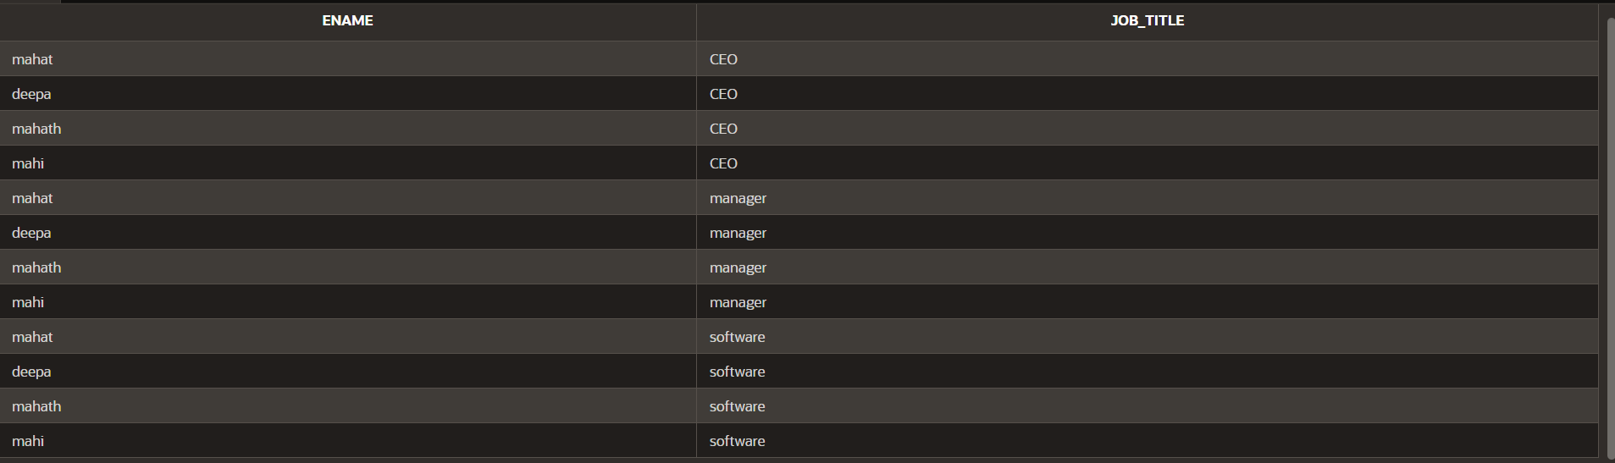

**JOIN:**

SELECT last_name, location

FROM Employes e, departments d, jobs j

WHERE e.job_id = j.job_id

AND e.department_id =d.department_id;

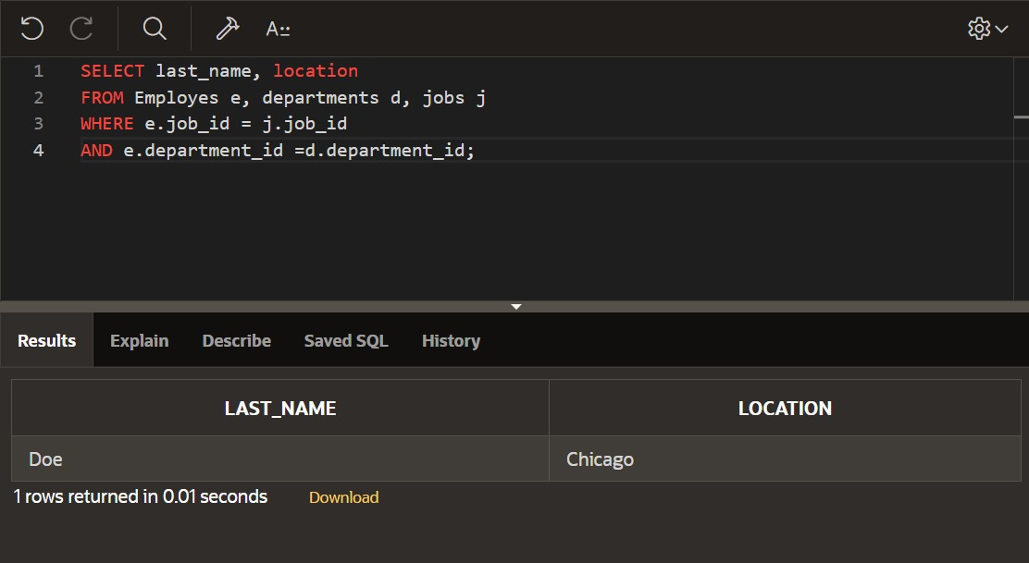

**NONEQUI JOIN:**

SELECT ename,salary,grade,lowsal,

highsal

FROM employ,job_grade

WHERE (salary BETWEEN lowsal AND highsal);

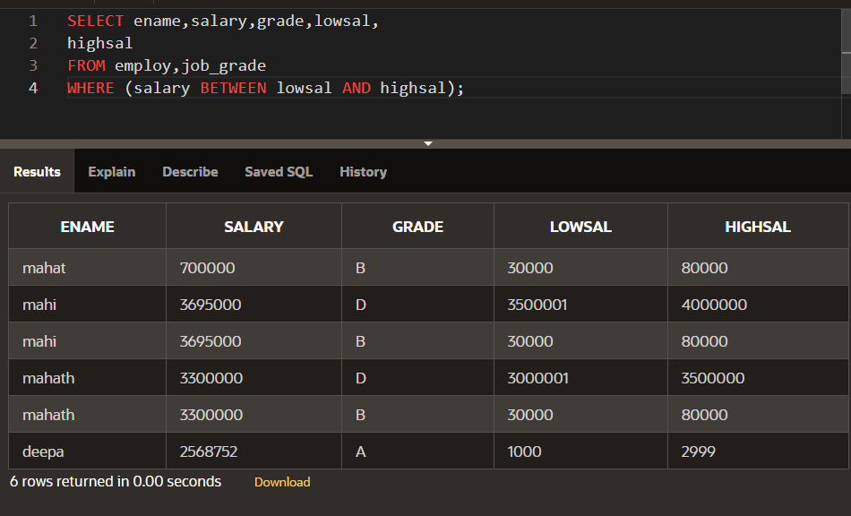

**SECTION_8**

**MAXIMUM:**

select max(salary)

as "max_salary"

FROM employee;

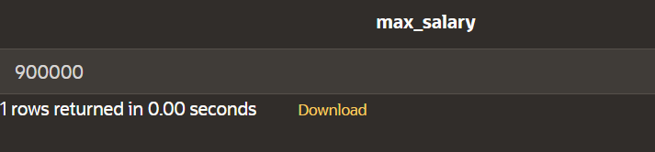

**SUM**:

select sum(salary)

from employee;

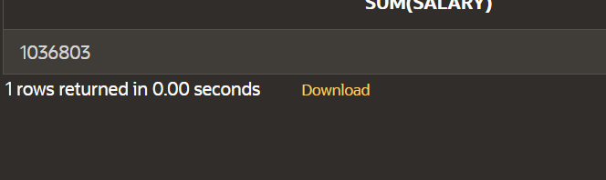

**AVERAGE:**

select avg(salary)

from employee

where job_id=1;

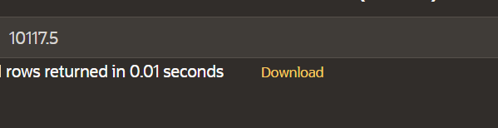

**ROUND AVERAGE:**

select round(avg(salary),0)

from employee

where job_id=1;

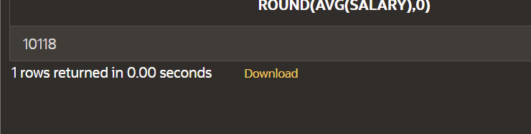

**ROUND VARIANCE:**

select round(variance(salary),0)

from employee

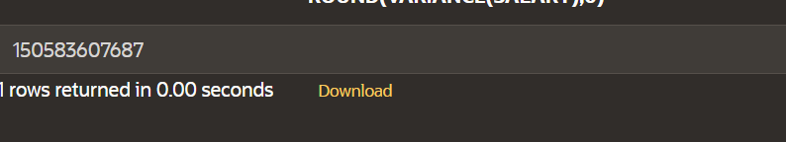

ROUND STDDEV:

select round(stddev(salary),1)

from employee

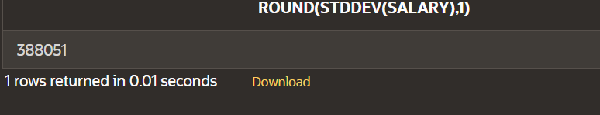

**COUNT**:

SELECT COUNT(job_id)

FROM employee;

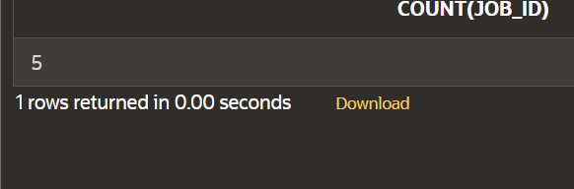

**COUNT ALL ROWS:**

SELECT COUNT(*)

FROM employee

WHERE job_id < 9;

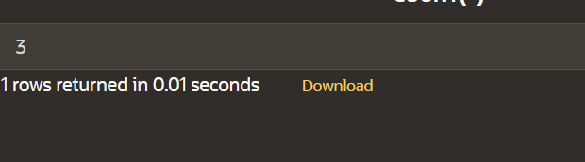

**SUM DISTINCT SALARY:**

SELECT SUM(distinct salary)

FROM employee

WHERE job_id = 9;

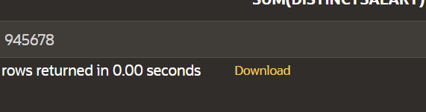

**COUNT(DISTINCT JOB_ID):**

SELECT COUNT (DISTINCT

job_id)

FROM employee**;**

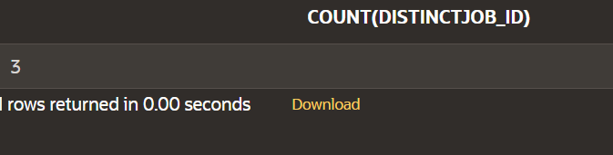

**NULL:**

select avg(nvl(salary,0))

from employee;

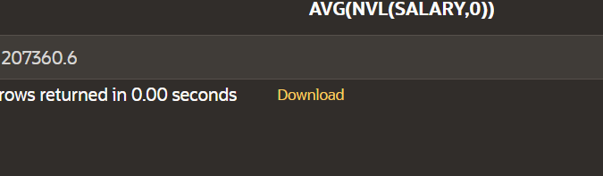

**GROUP AVERAGE:**

select avg(salary)

from employee

where job_id=9;

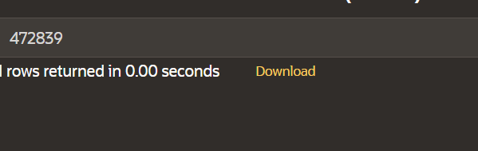

**GROUP BY USE:**

SELECT job_id, AVG(salary)

FROM employee

GROUP BY job_id

ORDER BY job_id;

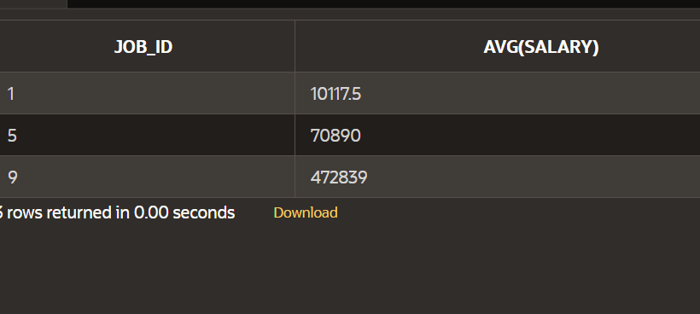

**GROUP BY MAX:**

SELECT MAX(salary)

FROM employee

GROUP BY job_id;

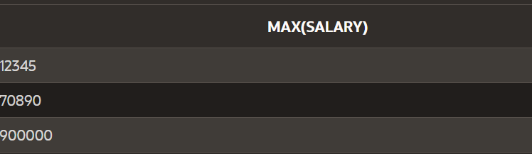

**GROUP BY COUNT:**

select count (e_name),job_id

from employee

group by job_id;

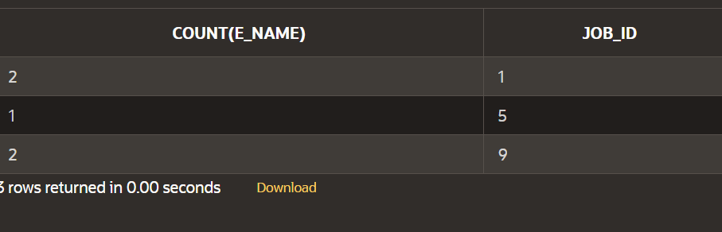

**COUNT BY COUNT (*):**

select count (*),job_id

from employee

group by job_id;

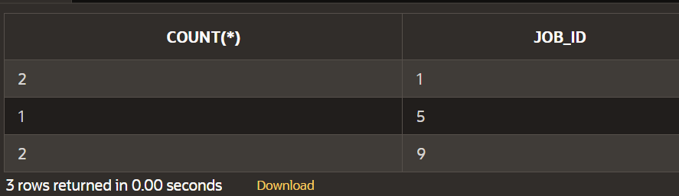

**GROUP BY WHERE:**

SELECT job_id, MAX(salary)

FROM employee

WHERE e_name != 'lucky'

GROUP BY job_id;

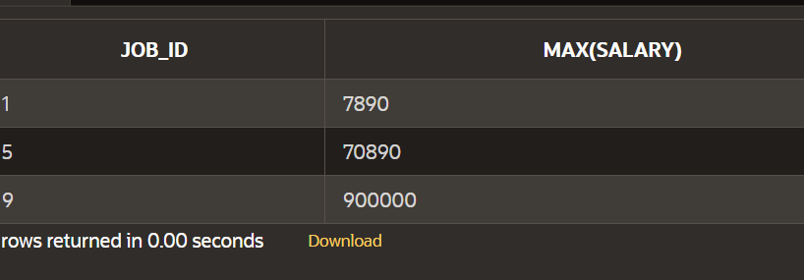

**GROUP WITHIN GROUPS:**

SELECT dept_no, job_id,

count(*)

FROM employee

WHERE dept_no > 40

GROUP BY dept_no, job_id;

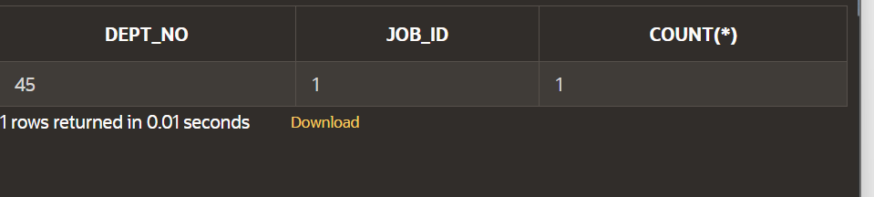

**NESTING GROUP FUNCTIONS:**

SELECT max(avg(salary))

FROM employee

GROUP by job_id;

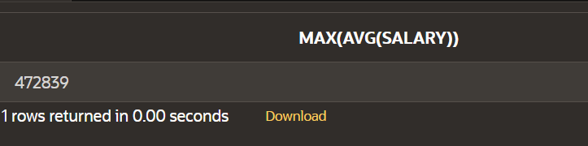

**SECTION 9**

**HAVING:**

SELECT dept_no,MAX(salary)

FROM employee

GROUP BY dept_no

HAVING COUNT(*)>1

ORDER BY dept_no

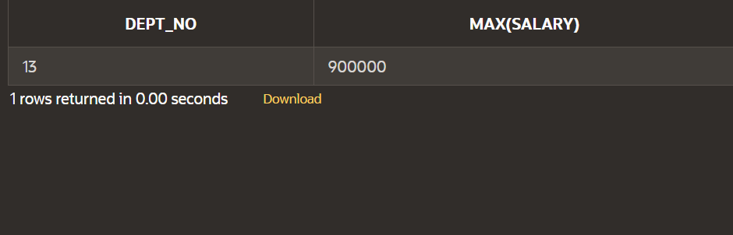

**ROLL UP:**

SELECT dept_no, job_id, SUM(salary)

FROM employee

WHERE dept_no < 50

GROUP BY ROLLUP (dept_no, job_id);

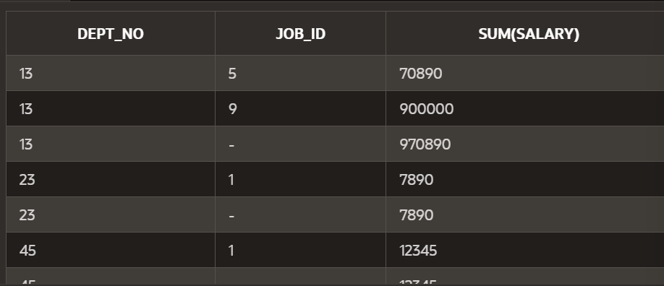

**WITHOUT ROLLUP:**

SELECT dept_no, job_id, SUM(salary)

FROM employee

WHERE dept_no < 50

GROUP BY (dept_no, job_id);

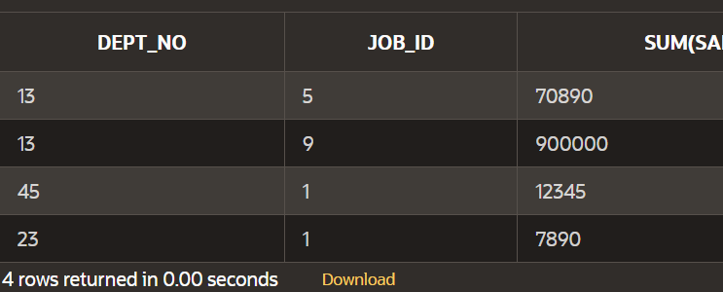

**CUBE:**

SELECT dept_no, job_id, SUM(salary)

FROM employee

WHERE dept_no < 50

GROUP BY cube (dept_no, job_id);

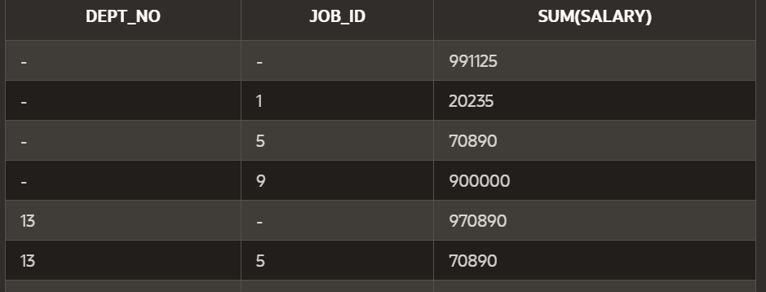

**GROUPING SETS:**

select emp_no,job_id,dept_no,sum(salary)

from employee

where dept_no<50

group by grouping sets

((emp_no,job_id),(job_id,dept_no),(dept_no,emp_no));

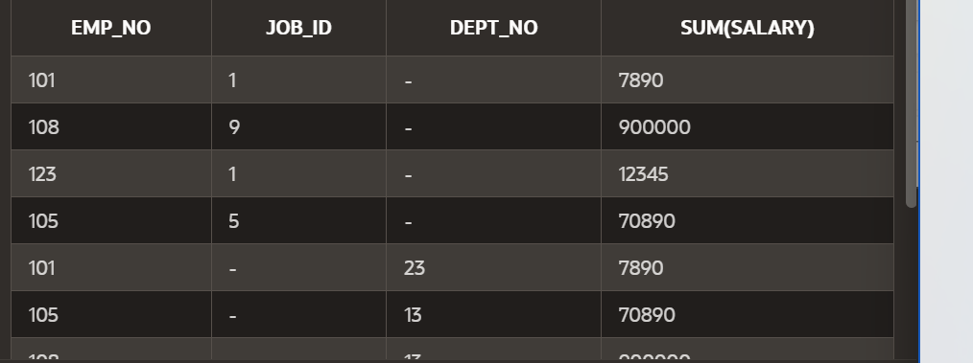

UNION:

SELECT emp_no

FROM employee

UNION

SELECT job_id

FROM job;



**UNION ALL:**

SELECT emp_no

FROM employee

UNION all

SELECT job_id

FROM job;

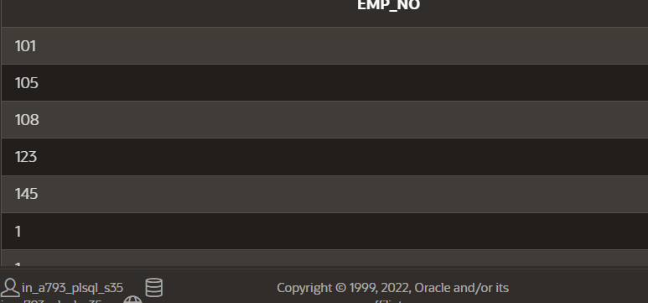

**SECTION-10**

**INTERSECT:**

SELECT emp_no

FROM employee

intersect

SELECT job_id

FROM job;

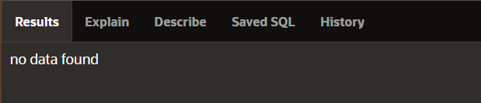

**MINUS:**

SELECT emp_no

FROM employee

minus

SELECT job_id

FROM job;



**SUBQUERY EXAMPLE:**

SELECT e_name,

emp_no

FROM employee

WHERE emp_no >

(SELECT emp_no

FROM employee

WHERE e_name = 'lucky');

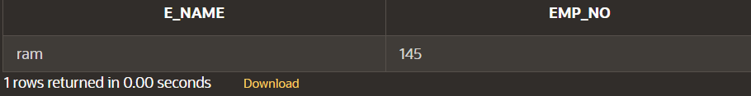

**SUBQUERY AND NULL:**

SELECT e_name,

emp_no

FROM employee

WHERE emp_no >

(SELECT emp_no

FROM employee

WHERE e_name = 'anji');

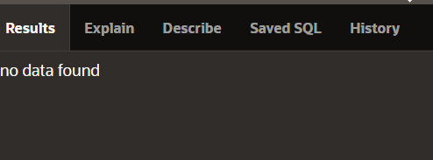

**SUBQUERY FROM DIFFERENT TABLES:**

SELECT e_name, job_id, dept_no

FROM employee

WHERE job_id =

(SELECT job_id

FROM job

WHERE job_name = 'teacher')

ORDER BY job_id;

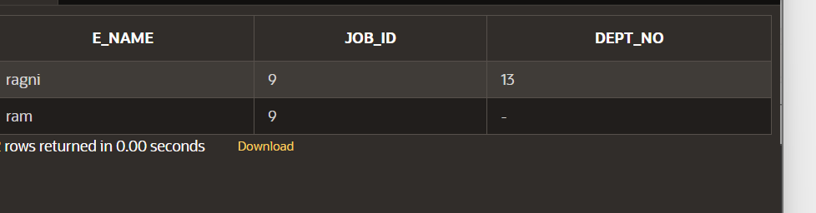

**GROUP FUNCTIONS IN SUBQUERIES:**

SELECT e_name, salary

FROM employee

WHERE salary <

(SELECT AVG(salary)

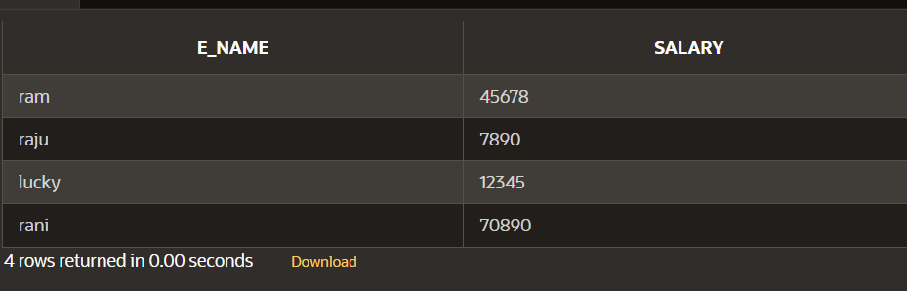FROM employee);

**CONCATENATION:**

select dept_no||''||dept_name

from employee;

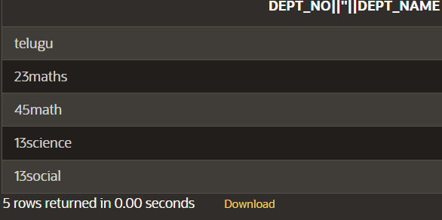

**SECTION_12**

**DEFAULT EXAMPLE:**

CREATE TABLE my_employees (

hire_date DATE DEFAULT SYSDATE,

first_name VARCHAR2(15),

last_name VARCHAR2(15)

);

**EXPLICIT DEFAULT EXAMPLE:**

INSERT INTO my_employees

(hire_date, first_name, last_name)

VALUES

(DEFAULT, 'anjali','raju');

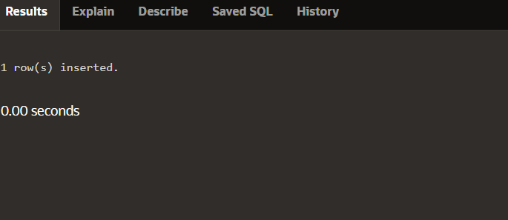

**IMPLICIT USE OF DEFAULT:**

INSERT INTO my_employees

(first_name, last_name)

VALUES

('Angelina','Wright');

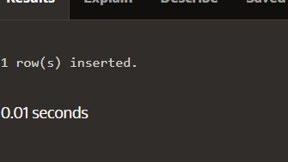

**EXPLICIT DEFAULT WITH UPDATE:**

UPDATE my_employees

SET hire_date = DEFAULT

WHERE last_name = 'Wright';

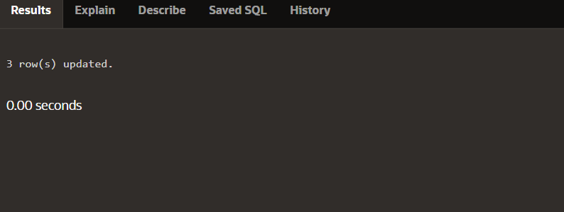

**CREATE A COPY OF THE TABLE:**

CREATE TABLE copy_employee

AS (SELECT * FROM employee);

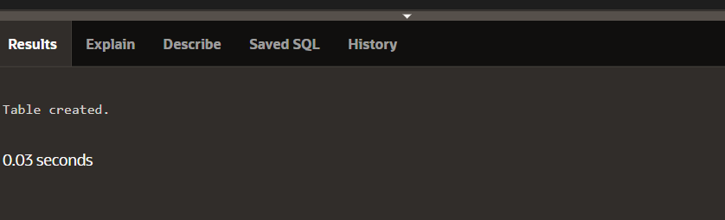

**CREATE A COPY OF JOB TABLE:**

CREATE TABLE copy_job

AS (SELECT * FROM job);

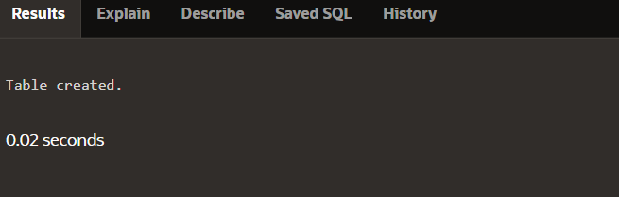

**DISPLAY COPY OF EMPLOYEE:**

SELECT * FROM copy_employee;

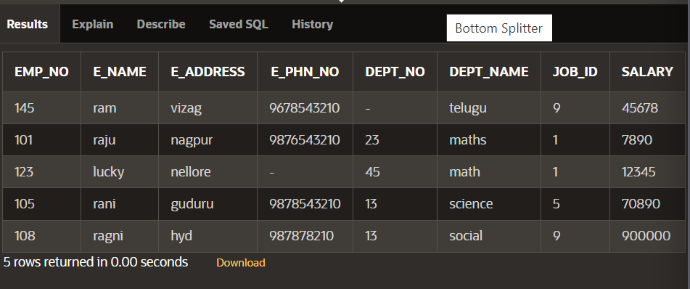

**DESCRIBE EMPLOYEE TABLE:**

DESCRIBE copy_job;

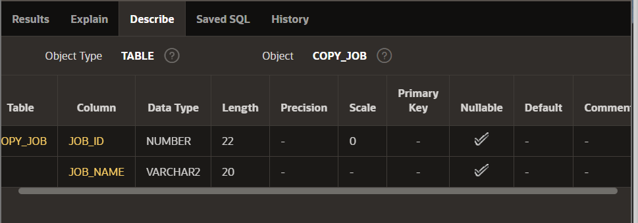

**INSERT INTO COPY OF JOB:**

INSERT INTO copy_job

(job_id, job_name)

VALUES (200,'Human Resource');

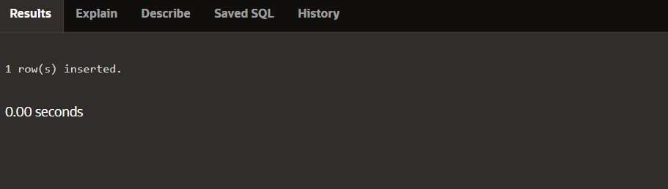

**Implicit insert into copy of job:**

INSERT INTO copy_job

VALUES

(210,'Estate Management');

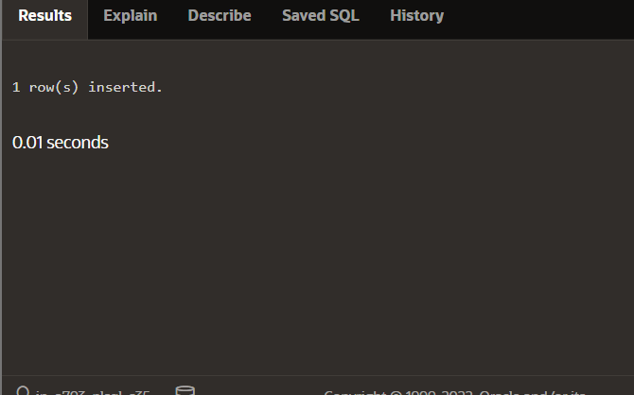

**Update**:

UPDATE copy_employee

SET job_id = '123456'

WHERE emp_no = 145;

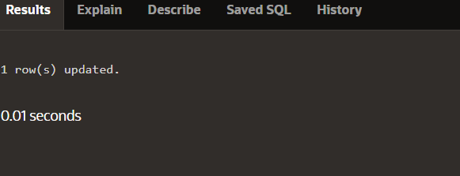

**Update copy of table:**

UPDATE copy_employee

SET emp_no = 243576, e_name = 'raju'

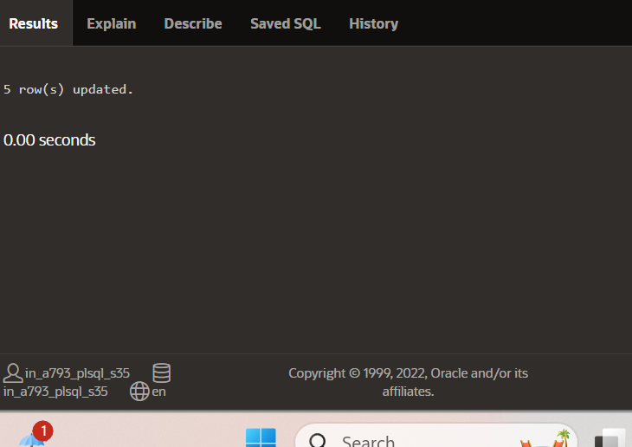

**Delete:**

DELETE from copy_employee

WHERE emp_no = 243576;

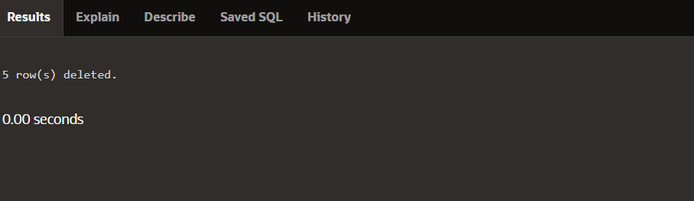

Subquery delete:

DELETE FROM copy_employees

WHERE department_id =

(SELECT department_id

FROM departments

WHERE department_name = 'Shipping');



**Section_13**

**CREATE TABLE MY FRIENDS:**

CREATE TABLE my_friends

(first_name VARCHAR2(20),

last_name VARCHAR2(30),

email VARCHAR2(30),

phone_num VARCHAR2(12),

birth_date DATE);

**CREATE TABLE MY CDCOLLECTION:**

CREATE TABLE my_cd_collection

(cd_number NUMBER(3),

title VARCHAR2(20),

artist VARCHAR2(20),

purchase_date DATE DEFAULT SYSDATE);

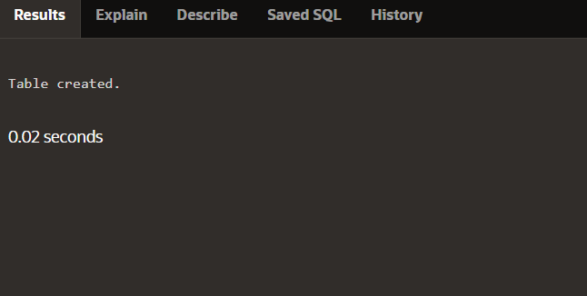

**DATA DICTIONARY:**

SELECT table_name, status

FROM USER_TABLES;

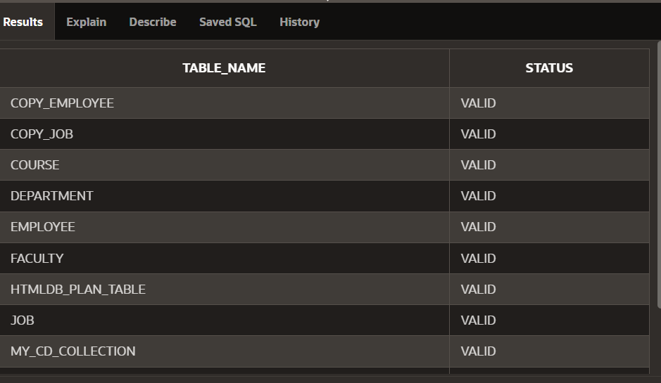

**DATA DICTIONARY TABLE NAME:**

SELECT table_name, status

FROM ALL_TABLES;

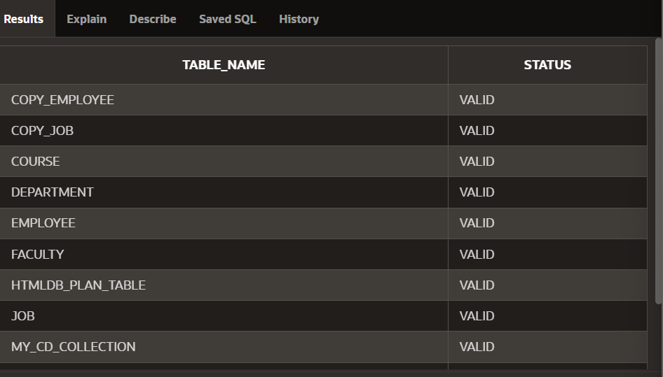

**TIMES STAMP TABLE:**

CREATE TABLE time_ex1

(exact_time TIMESTAMP);

**TIMES STAMP TABLE INSERT ROW:**

INSERT INTO time_ex1

VALUES ('8-aug-2024 10:52:29.123456'); 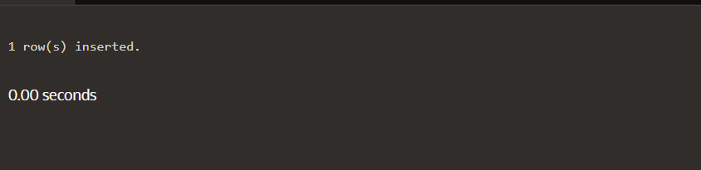

**TIMES STAMP TABLE INSERT ROW USING SYS UPDATE:**

INSERT INTO time_ex1

VALUES (SYSDATE);

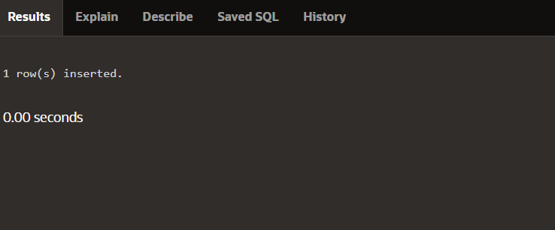

**SYS UPDATE:**

INSERT INTO time_ex1

VALUES (SYSTIMESTAMP);

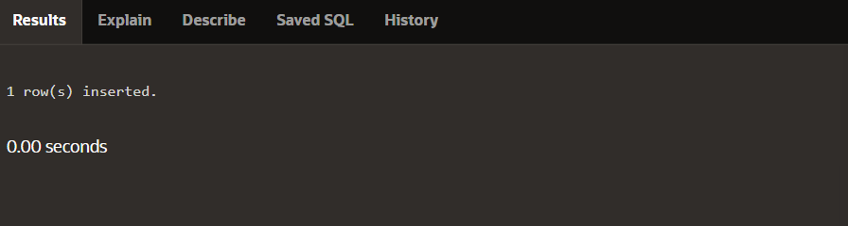

**DISPLAY TIME STAMP:**

SELECT *

FROM time_ex1;

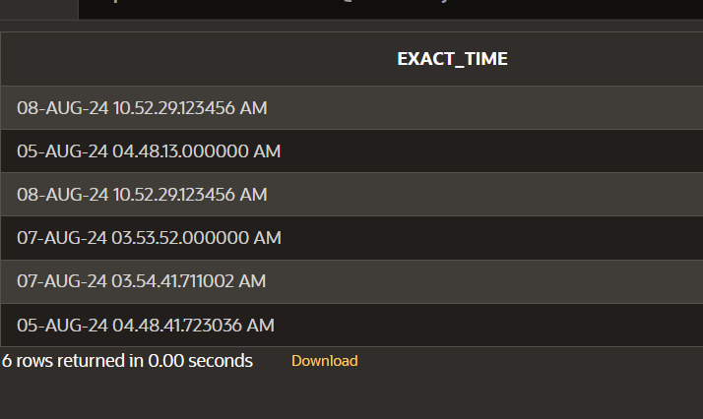

**CREATE TABLE:**

CREATE TABLE time_ex4

(loan_duration1 INTERVAL YEAR(3) TO MONTH,

loan_duration2 INTERVAL YEAR(2) TO MONTH);

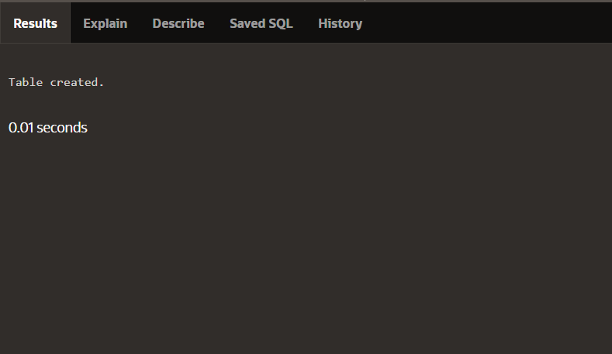

**INSERT :**

INSERT INTO time_1(loan_duration1, loan_duration2)

VALUES (INTERVAL '120' MONTH(3),

INTERVAL '3-6' YEAR TO MONTH);

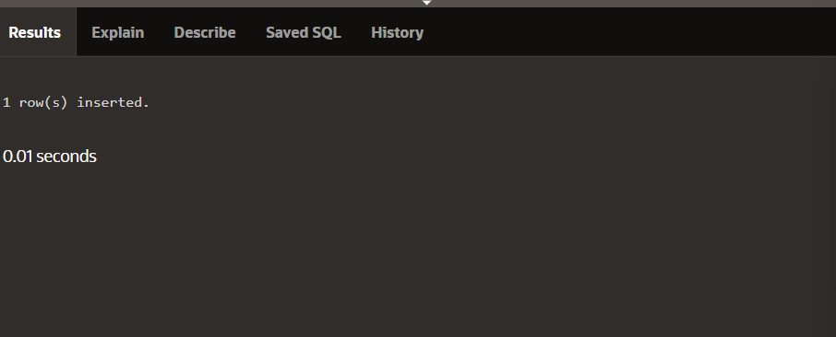

INTERVAL MONTH TO YEAR:

SELECT SYSDATE + loan_duration1 AS "120 months from now",

SYSDATE + loan_duration2 AS "3 years 6 months from

now"

FROM time_1;

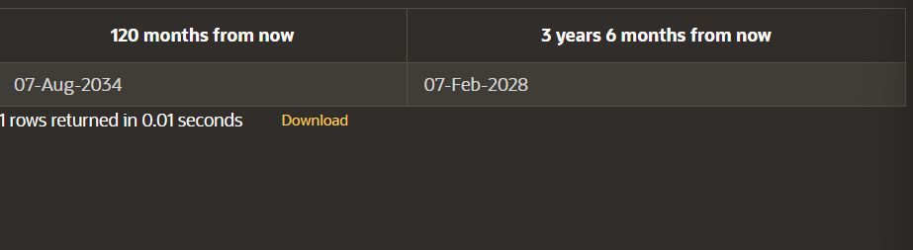

**DAY TO SECOND:**

CREATE TABLE time_2

(day_duration1 INTERVAL DAY(3) TO SECOND,

day_duration2 INTERVAL DAY(3) TO SECOND);

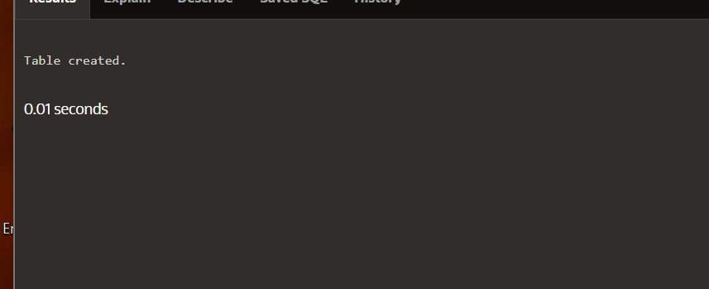

**DAY TO SECOND INSERT ROW:**

INSERT INTO time_2 (day_duration1, day_duration2)

VALUES (INTERVAL '25' DAY(2), INTERVAL '4 10:30:10' DAY TO

SECOND);

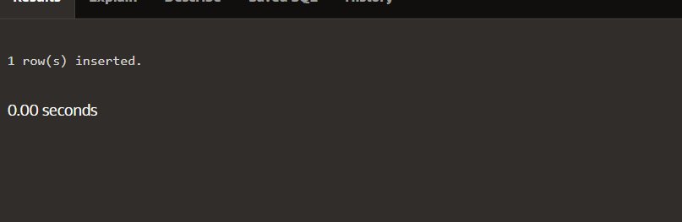

**DAY TO SECOND SELECT:**

SELECT SYSDATE + day_duration1 AS "25 Days from now",

TO_CHAR(SYSDATE + day_duration2, 'dd-Mon-yyyy hh:mi:ss')

AS "precise days and time from now"

FROM time_2;

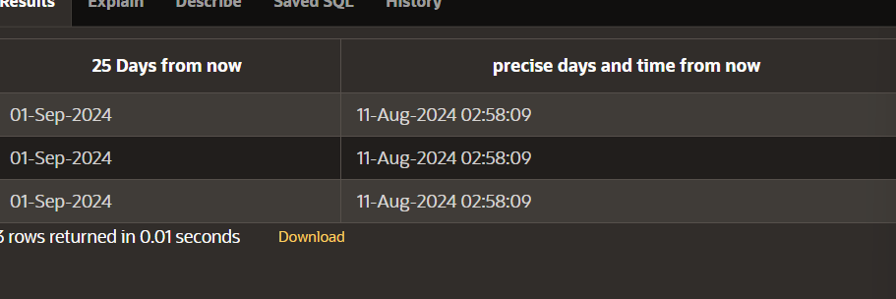

**SECTION 14**

**CREATING TABLE:**

CREATE TABLE clients (

client_number NUMBER(4),

first_name VARCHAR2(14),

last_name VARCHAR2(13));

CREATING CONSTRAINTS

CREATE TABLE clients

(client_number NUMBER(4) CONSTRAINT clients_client_num_pk

PRIMARY KEY,

first_name VARCHAR2(14),

last_name VARCHAR2(13));

COLUMN LEVEL

CREATE TABLE clients

(client_number NUMBER(4) CONSTRAINT clients_cient_num_pk PRIMARY KEY,

last_name VARCHAR2(13) CONSTRAINT clients_last_name_nn NOT NULL,

email VARCHAR2(80) CONSTRAINT clients_emil_uk UNIQUE);

**TABLE LEVEL:**

CREATE TABLE clients (

client_number NUMBER(6) NOT NULL,

first_name VARCHAR2(20),

last_name VARCHAR2(20),

phone VARCHAR2(20),

email VARCHAR2(10) NOT NULL,

CONSTRAINT clients_phone_email_uk UNIQUE (email,phone));

)

**VIOLATION:**

CREATE TABLE clients(

client_number NUMBER(6),

first_name VARCHAR2(20),

last_name VARCHAR2(20),

phone VARCHAR2(20) CONSTRAINT phone_email_uk

UNIQUE(email,phone),

email VARCHAR2(10) CONSTRAINT NOT NULL,

CONSTRAINT emailclients_email NOT NULL,

CONSTRAINT clients_client_num_pk PRIMARY KEY (client_number));

**UNIQUE CONSTRAINT:**

INSERT INTO clients (client_number, first_name, Last_name, phone,

email)

VALUES (7234, 'Lonny', 'Vigil', 4072220091, 'lbv@lbv.net');

PRIMARY KEY

CREATE TABLE clients

(client_number NUMBER(4) CONSTRAINT clients_client_num_pk

PRIMARY KEY,

first_name VARCHAR2(14),

last_name VARCHAR2(13));

**TABLE LEVEL:**

CREATE TABLE copy_job_history

(employee_id NUMBER(6,0),

start_date DATE,

job_id VARCHAR2(10),

department_id NUMBER(4,0),

CONSTRAINT copy_jhist_id_st_date_pk PRIMARY KEY(employee_id,

start_date));

FOREIGN KEY

CREATE TABLE copy_employees

(employee_id NUMBER(6,0) CONSTRAINT copy_emp_pk PRIMARY KEY,

first_name VARCHAR2(20),

last_name VARCHAR2(25),

department_id NUMBER(4,0),

email VARCHAR2(25),

CONSTRAINT c_emps_dept_id_fk FOREIGN KEY (department_id)

REFERENCES departments(department_id));

ON DELETE CASCADE

CREATE TABLE copy_employees

(employee_id NUMBER(6,0) CONSTRAINT copy_emp_pk PRIMARY KEY,

first_name VARCHAR2(20),

last_name VARCHAR2(25),

department_id NUMBER(4,0),

email VARCHAR2(25),

CONSTRAINT cdept_dept_id_fk FOREIGN KEY (department_id)

REFERENCES copy_departments(department_id));

**SECTION_15**

**VIEW:**

CREATE VIEW view_employee

AS SELECT emp_no,e_name,job_id

FROM employee

WHERE emp_no BETWEEN 100 and 243569;

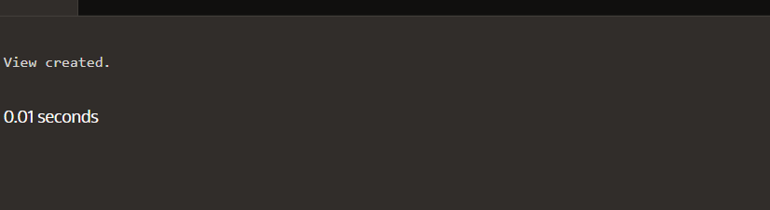

**VIEWING THE TABLE:**

SELECT *

FROM view_employee;

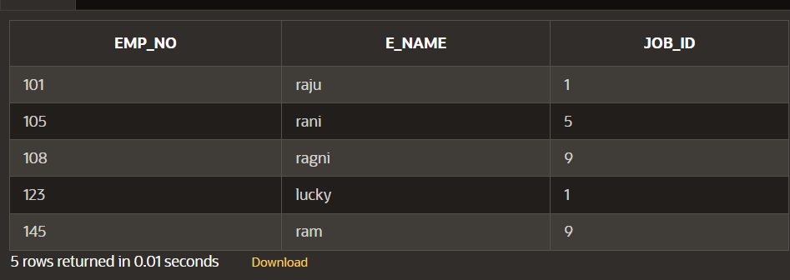

**CREATING A VIEW:**

CREATE OR REPLACE VIEW view_employee

AS SELECT job_id, emp_no, e_name

FROM employee

WHERE emp_no LIKE '%43567';

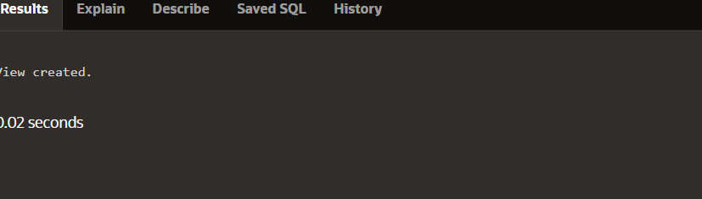

**VIEW:**

SELECT * FROM employee

ORDER BY e_name;

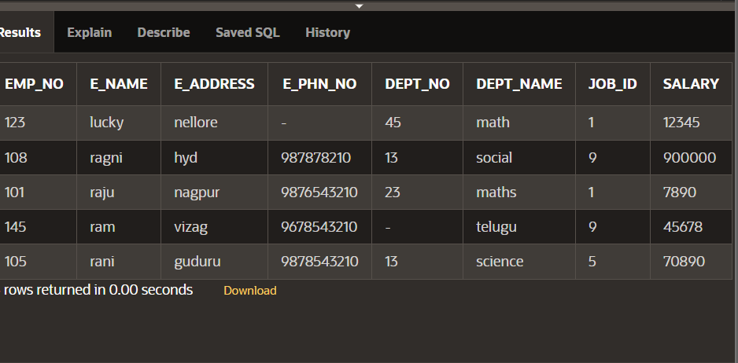

**SIMPLE VIEW:**

CREATE OR REPLACE VIEW view_employee

AS SELECT job_id, emp_no, e_name

FROM employee

WHERE emp_no LIKE '%43567';

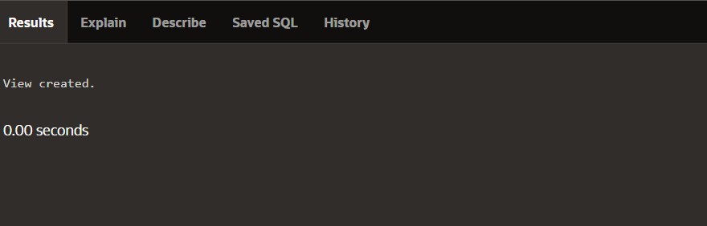

**Simple view with columns :**

CREATE OR REPLACE VIEW view_employee

AS SELECT job_id as id , emp_no as e_no, e_name as name

FROM employee

WHERE emp_no LIKE '%43567';

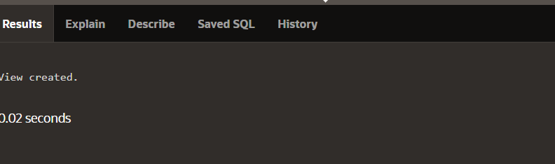

**MODIFYING A VIEW:**

CREATE OR REPLACE VIEW view_employee

AS SELECT emp_no,job_id,e_name,salary

FROM employee

WHERE emp_no LIKE '%43567';

